**Epigenetics**

* Gene expressions: The process of **copying information from DNA onto mRNA** and **translating the message** into a **series of amino acids**.
* Protein synthesis: The process that the genetic code within the nucleus is used to **produce structural or metabolic proteins** (not genetic).
* Epigenetics: The non-genetic processes (environmental factors) that **change the gene expression** of the genetic code.
* DNA is **coiled around histones**.

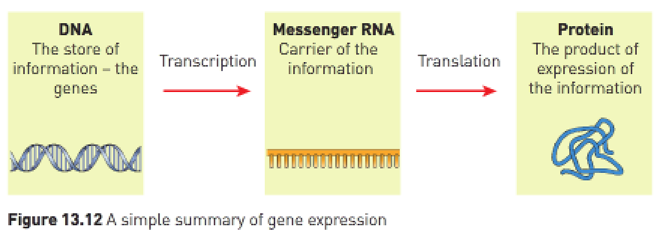

* Genes that are being **used to make mRNA** are said to be “switched **on**”.
* Genes **not** being **used to make mRNA** are said to be “switched **off**”.
* If the DNA is coiled **tightly** (called DNA **methylation**) the **RNA polymerase can’t form mRNA** and therefore the process of **protein synthesis can’t occur**.
* **Methyl** molecules bind to DNA and **block access to genes**. Tightly coiled DNA is inaccessible to RNA polymerase.
* If the histones move **further away** from each other (called DNA **acetylation**) the **RNA polymerase can build mRNA** and **protein synthesis can occur**.
* **Acetyl** molecules bind to histones and **improve access to genes**.
* Environmental (**epigenetic**) factors e.g., diet exercise, etc. **influence DNA methylation and/or histone acetylation** and therefore **acts to switch genes on or off**.
* Methyl and acetyl **control gene expression** by **controlling access to DNA**.
* RNA polymerase in the cell is **blocked by methyl** that **binds directly to DNA** or when DNA is **wound tightly around histones**.
* Access is easier when **acetyl causes DNA** to be **wound more loosely around histones**.
* **Enzymes** play an important role in gene expression by **facilitating the addition and removal of methyl and acetyl**.